

# North South University

Department of Electrical & Computer Engineering CSE323 Project Term Report

**Course Code:** CSE323

**Course Title:** Operating System Design

# Section: 03

**Submitted by:** Habibur Rahaman Fahim

**ID:** 1911753642

**Submitted to:** Mosabber Uddin Ahmed (MUA3)

**Date of Submission:** 20th June 2023

**Digital Clock System**

# Abstract

The 16x2 LCD screen and Arduino Nano microcontroller will be used in the Digital Clock System project to design and build a twelve-hour digital clock. The goal of the project is to develop a digital clock system that displays time digitally rather than with conventional analog clock hands at a low cost and with ease of replication. The project is thoroughly described in this report, including the hardware design, materials utilized, steps taken, and project importance in numerous applications.

# Objective

Using an Arduino Nano, a 16x2 LCD screen, push buttons, resistors, a breadboard, and jumper wires, the Digital Clock System project's goal is to create a 12-hour digital clock that shows the time digitally. With straightforward hardware components, the project intends to offer a reasonably cheap method for creating a digital clock.

# Procedure

The Digital Clock System is created and run according to the following processes:

* The Arduino IDE, which offers an integrated development environment for programming the Arduino Nano, should be downloaded and installed first. Hardware association Using jumper wires and a breadboard, attach the Arduino Nano, 16x2 LCD display, pushbuttons, and resistors while making sure the pin connections and voltage division are correct.
* Write the required Arduino code using the Arduino IDE, making sure to include routines for reading button inputs, resetting the time, and managing LCD displays.
* To establish connection between the Arduino IDE and the Arduino Nano, select the relevant board (Arduino Nano) and port (such as COM4 or COM6) in the Arduino IDE.

# Hardware Design

To provide the needed functionality, a number of hardware parts were carefully integrated components make up the hardware design of the Digital Clock System.

* **Arduino Nano:** The Arduino Nano is a small, reasonably priced microcontroller board that has the computing capability to manage a digital clock system.
* **16x2 LCD Screen:** The 16x2 LCD screen has two rows of 16 characters each, giving it plenty of room to clearly display the time.
* **Push Buttons:** To enable user interaction for setting the time and time format, three tactile push buttons are used.
* **Resistors:** To control current flow and safeguard the components, resistors with the proper resistance values are connected in series with each push button.
* **Breadboard:** The circuit is assembled on a temporary breadboard to allow for easy testing and customization.
* **Jumper Wires:** To make the necessary electrical connections between the components, jumper wires of the proper lengths and kinds are used.

Here’s the hardware diagram:

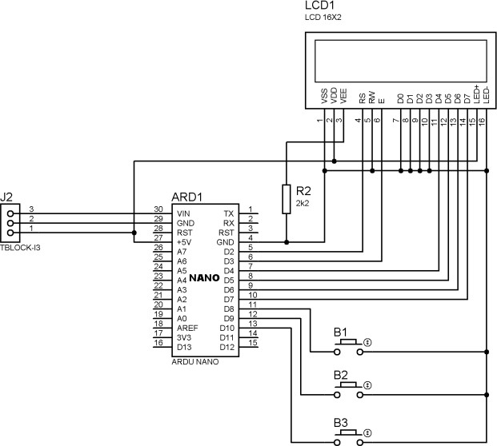

# Result

Using an Arduino Nano and a 16x2 LCD screen, the Digital Clock System project successfully created a twelve-hour digital clock. Push buttons, resistors, and a breadboard were used to implement the project's hardware. The clock provides the current time with accuracy and has room for improvement.

# Obstacles

Writing the code right for the Arduino IDE was the biggest issue of this project. In addition to responding to the push buttons, the code had to be able to display the time in a twelve- hour format.

# Conclusion

In conclusion, the project's goal of using an Arduino Nano and a 16x2 LCD screen to create a 12-hour digital clock was accomplished. The project showcased the development of Arduino code for timekeeping and display as well as the integration of hardware components. Its functionality and applicability in different applications can be improved with additional upgrades and expansions.

# References & Resources

1. [Arduino Nano](https://www.aliexpress.com/item/4000587268145.html?spm=portals._adcenter_a%20ffiliateProductSearch.0.0.a5e12fe06LnTO8&amp;aff_fcid=b66999be61364db2b111a95e%20616f226b-1687241324732-09571-)
2. [16x2 LCD Display](https://www.aliexpress.com/item/32511014601.html?aff_fcid=e2d5807a8ea84c98%2087946dd4c3901646-1687241611801-04981-dTNRVcG&amp;terminal_id=337c745adb6c4f85aa680a9a08d5fe67&amp;afSmartRedirect=y)
3. [Resistor](https://www.aliexpress.com/item/32847096736.html?aff_fcid=1f79671f636e4617%20b1bee9ceb20f4e7b-1687241705292-09194-)
4. [Push Button](https://www.aliexpress.com/item/1058764733.html?spm=portals._adcenter_affili%20ateProductSearch.0.0.3a182fe0DyGwrC&amp;aff_fcid=9f3f54f5721549bd946d3f05f818%203a7c-1687241812548-08806-_dVr8HeN&amp;aff_fsk=_dVr8HeN&amp;aff_platform=portals-tool&amp;sk=_dVr8HeN&amp;aff_trace_key=9f3f54f5721549bd946d3f05f8183a7c-1687241812548-08806-)
5. [Bread Board](https://s.click.aliexpress.com/e/_dUBCOhh)
6. [Jumper](https://www.aliexpress.com/item/33027953616.html?aff_fcid=c29a19756b9840d1%2090af042e3550783d-1687243573542-06253-)
7. T. K. Gannavaram V, R. Bejgam, S. B. Keshipeddi, S. Sunkari and V. K. Aluvala, "Conversion of Sound Energy into Electrical Energy in Highly Populated Areas," 2021 6th International Conference on Communication and Electronics Systems (ICCES), 2021, pp. 32-36, doi: 10.1109/ICCES51350.2021.9489219.
8. Tummanapally, Shraddha Shree and Sunkari, Saideep, Smart Vehicle Tracking System using GPS and GSM Technologies (July 12, 2021). Available at SSRN: https://ssrn.com/abstract=3884903 or [http://dx.doi.org/10.2139/ssrn.3884903.](http://dx.doi.org/10.2139/ssrn.3884903)
9. Intelligent digital alarm clock 2018 IEEE 4th Information Technology and Mechatronics Engineering Conference (ITOEC) Year: 2018 | Conference Paper

|Publisher: IEEE